**Hive Assignment:**

**Problem statement 1:**

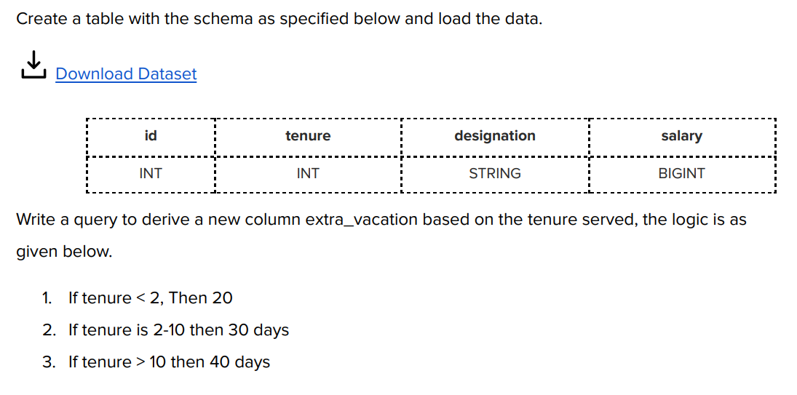

**Sol:**

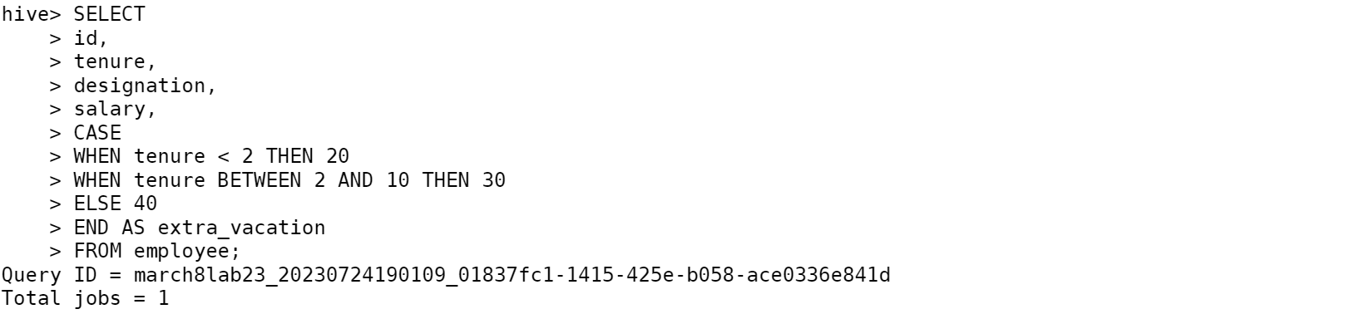

**Problem statement 2:**

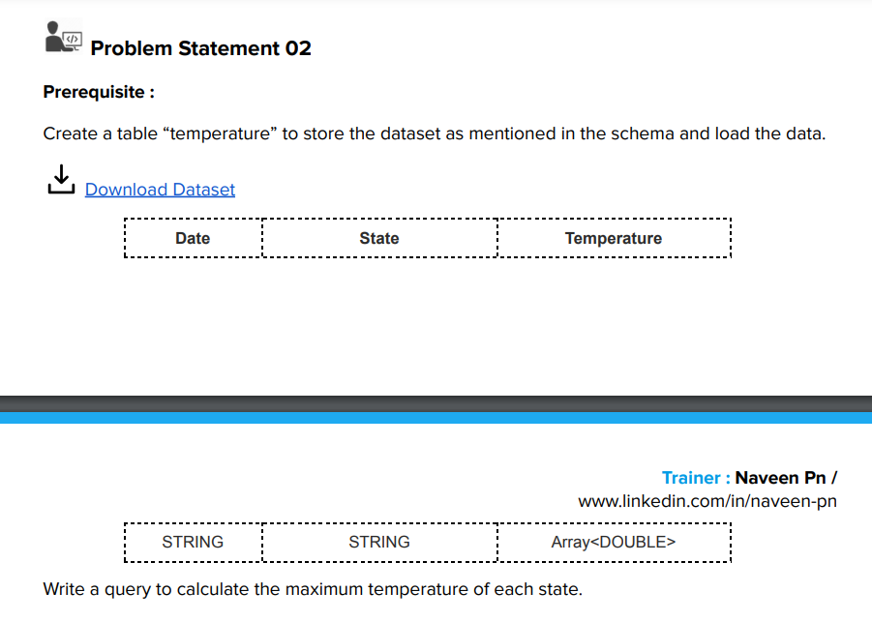

**Sol:**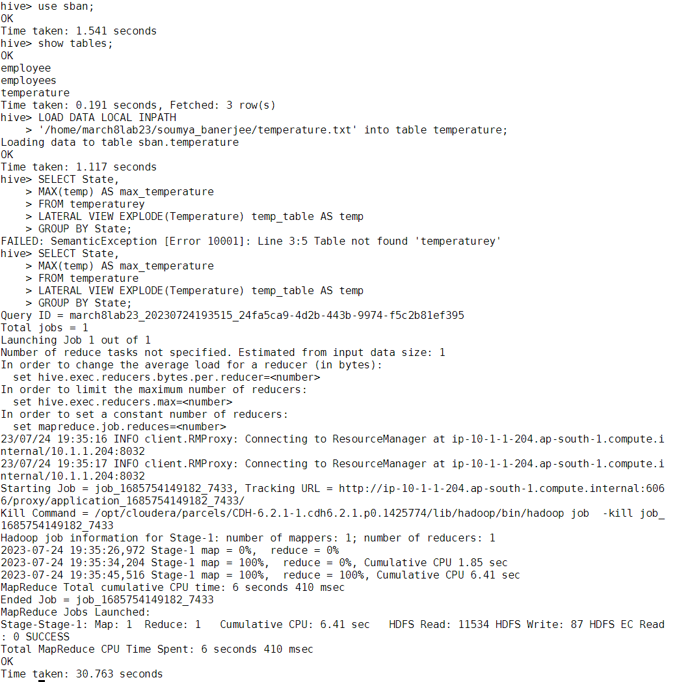

**Problem statement 3:**

**Sol:**

**Display NAME who has scored more than 90 in subject Maths subject**

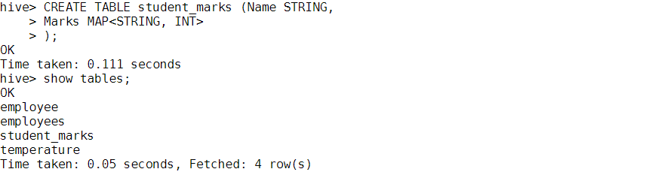

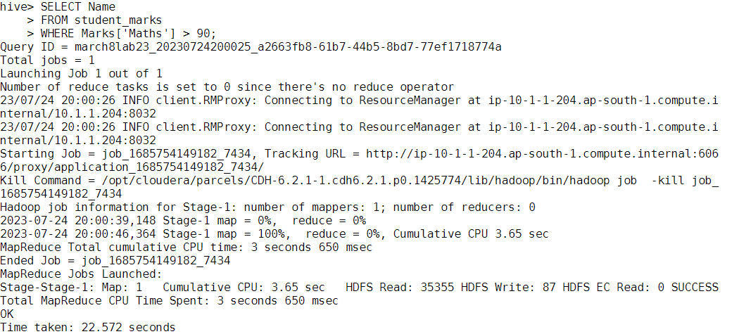

**Display NAME and Marks scored in physics**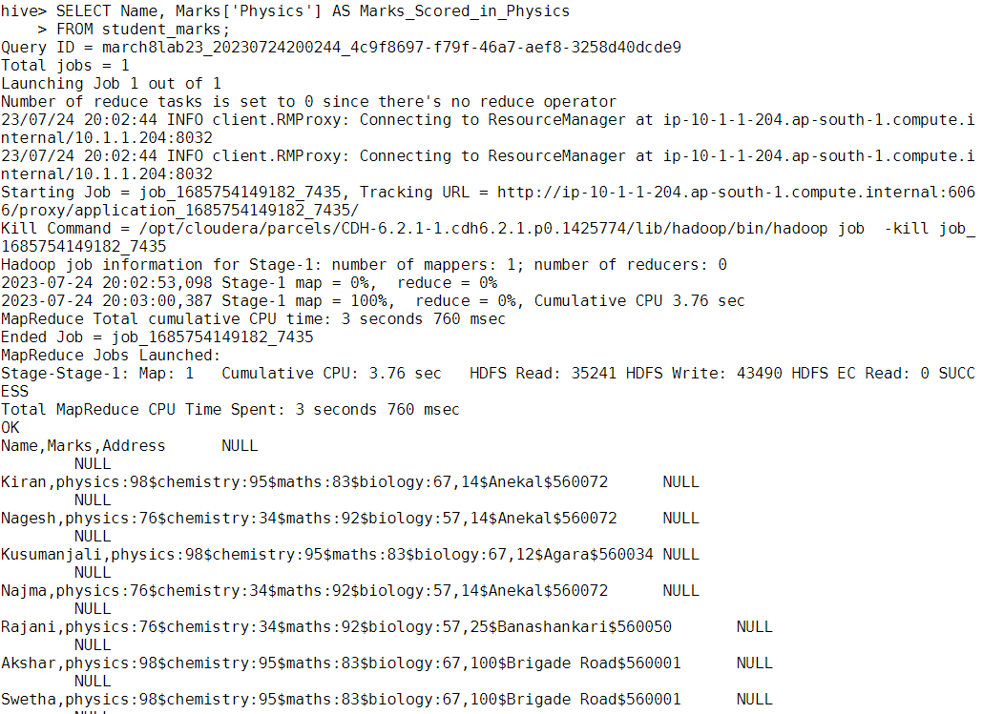

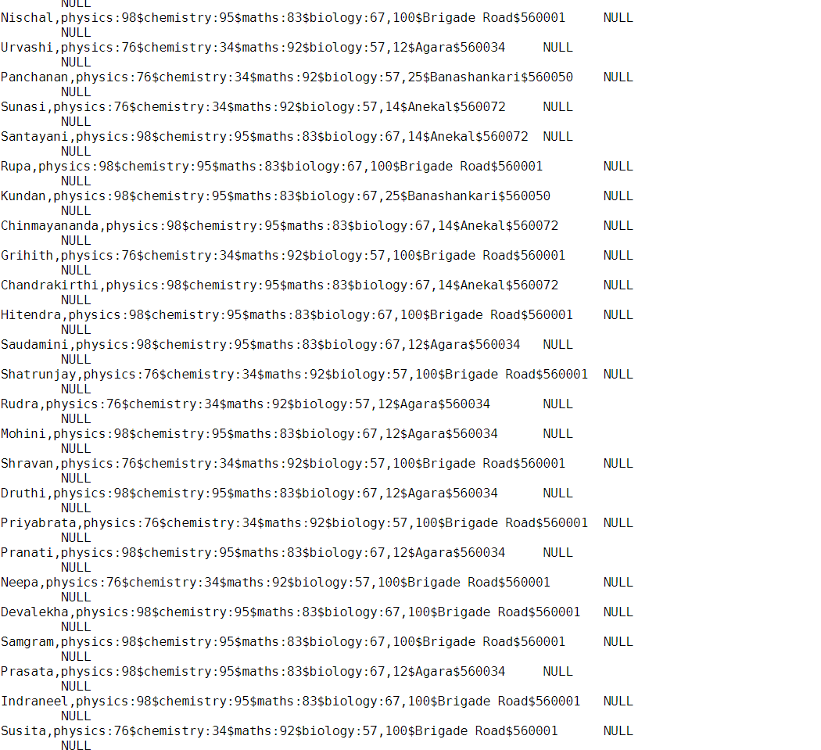

**Display NAME, and Maximum subject marks**

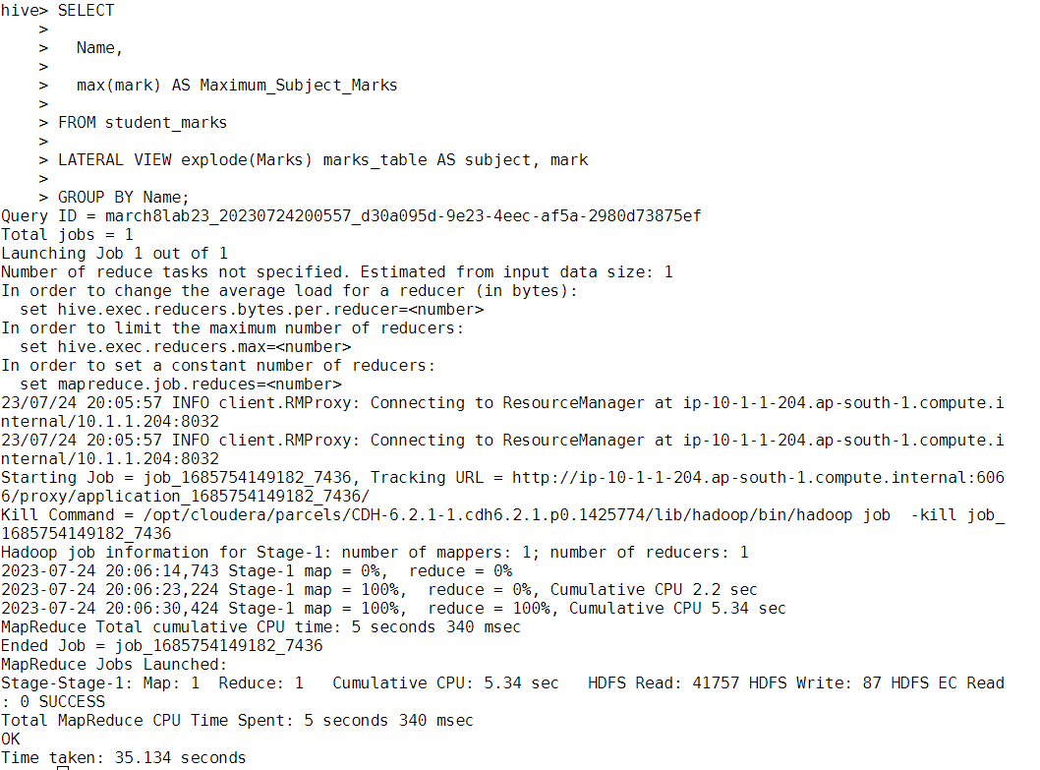

**Display NAME and Average marks scored**

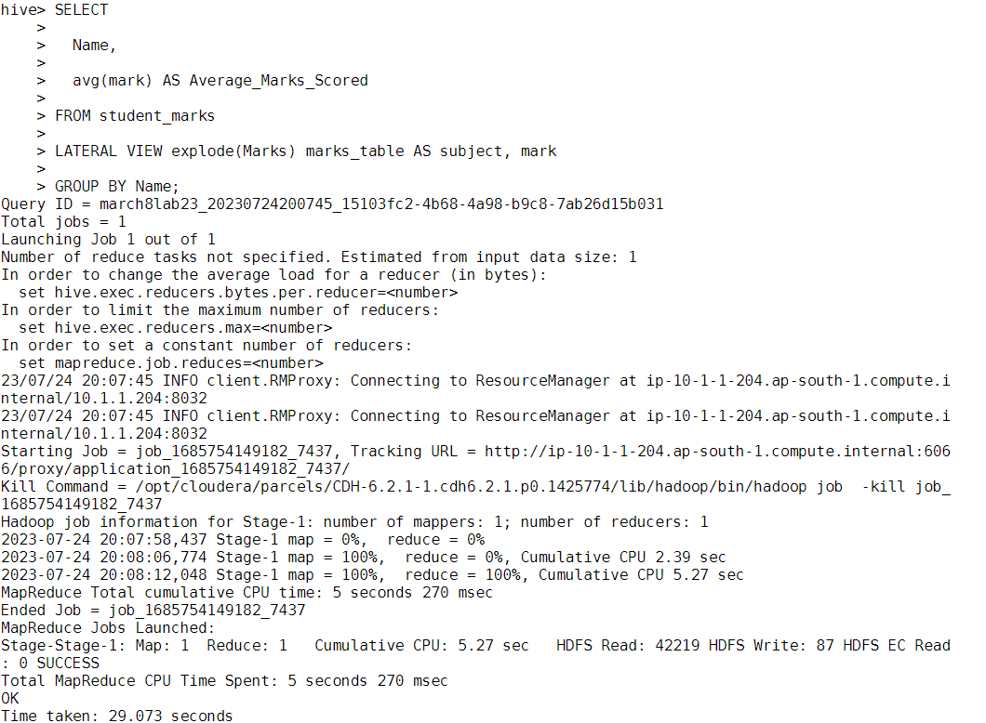

**Display Name and Percentage of marks**

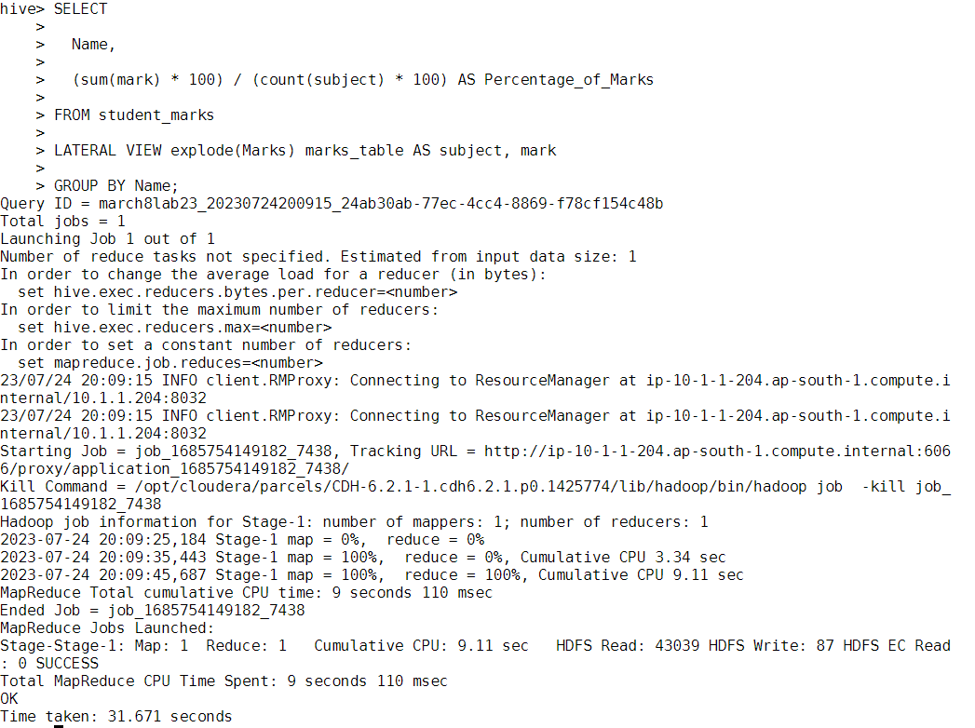

**Problem statement 4:**

**Sol:**

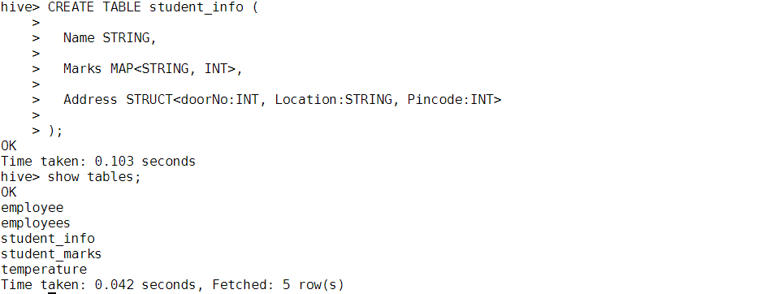



**All the names located in banashakari**

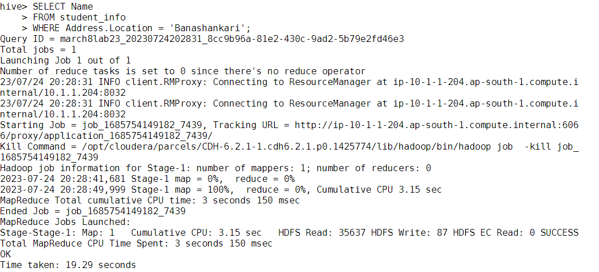

**Total count of individuals residing in pin code ‘560001’**

